- Lab Title: Lab 0: XAMPP Installation on Kali Linux

- Assignment Title: Lab 0: XAMPP Installation on Kali Linux
- Student Name: Bashir Adam
- Student ID: 2025/FWSD/11509
- Course Name: BVWS102 – OWASP-Top-10-Vulnerabilities-Exploitationentials
- Instructor Name: Aminu Idris
- Date of Submission: 23 JAN, 2026
- Version: Version 2.0.0

LAB OVERVIEW/OBJECTIVE

Objective:
To install XAMPP (a free and open-source cross-platform web server solution stack package) on Kali Linux for hosting web applications. This will set up a local environment for testing and experimenting with vulnerable web applications.

Prerequisites:
- A Kali Linux machine (physical or virtual).
- Internet connection for downloading XAMPP.

Step 1: Update Kali Linux Repositories

I first of all start by updating and upgrading my system to ensure accurate performance

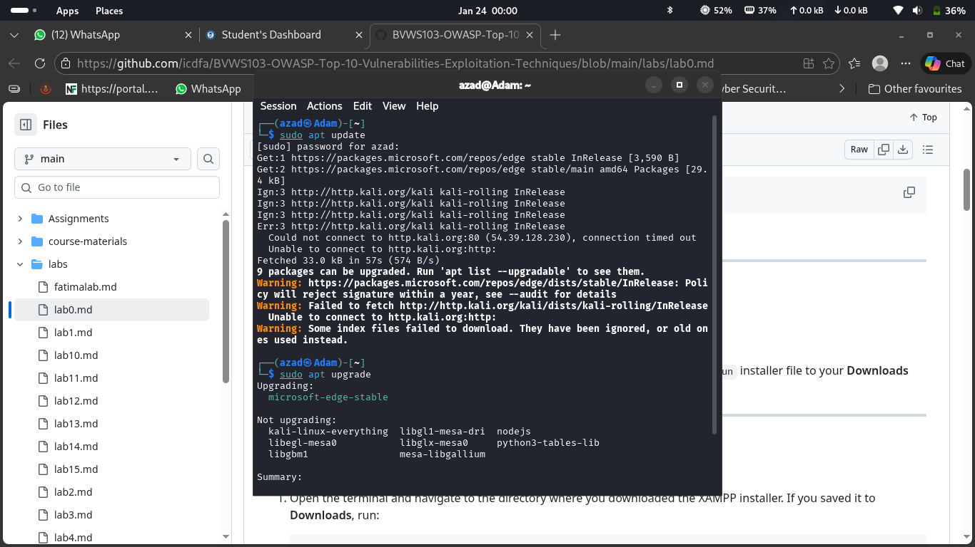

Then I perfectly download the XAMPP for linux application in the sourceforce web

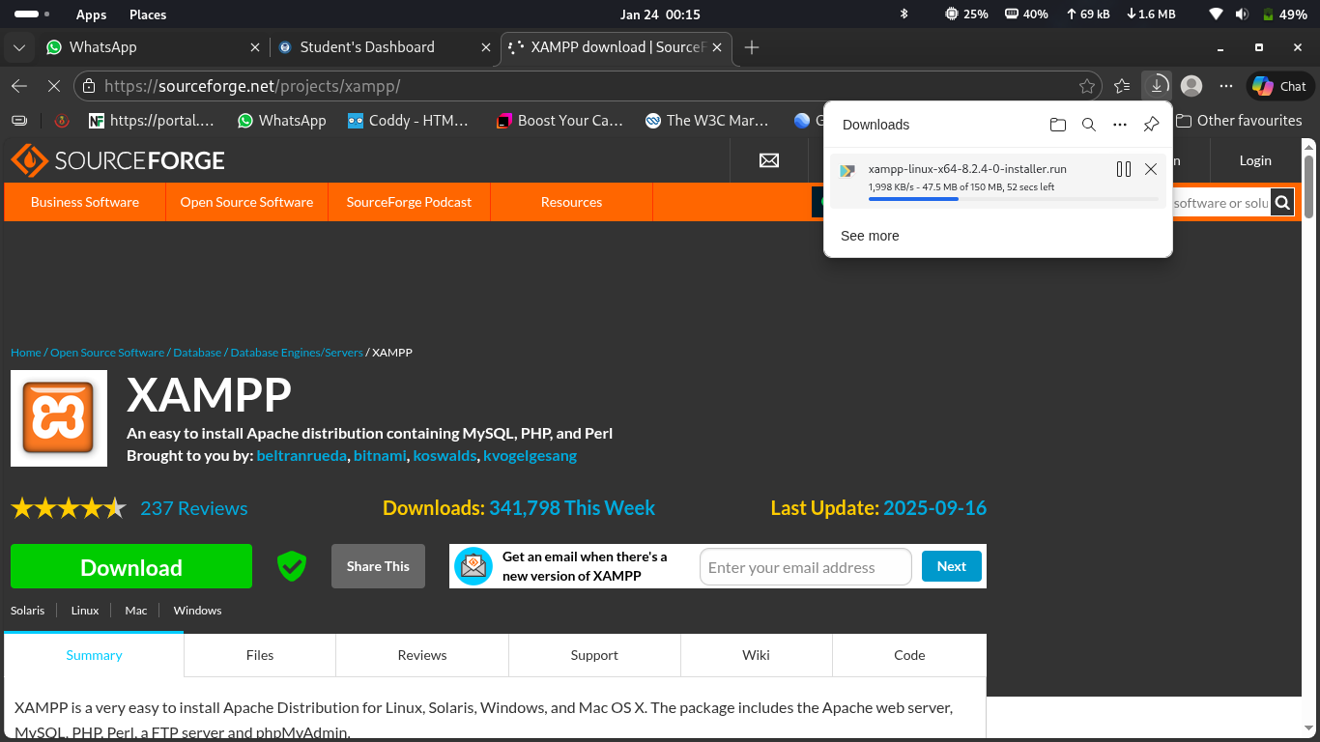

Then through my terminal I navigate to the Download directory using the command “cd ~/Downloads” and I use the command “chmod +x xampp-linux-x64-8.0.30-0-installer.run” to exacute the file so it can be exacutabl.

I then use the command “sudo ./xampp-linux-x64-8.0.30-0-installer.run” to run the file and istall it

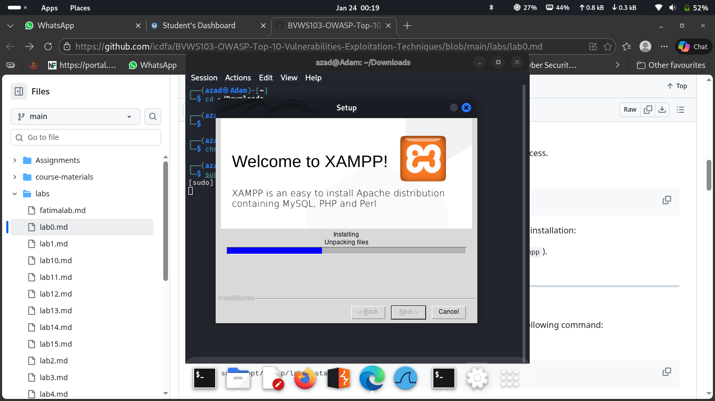

I start the XAMPP app manually to configure all accuracy

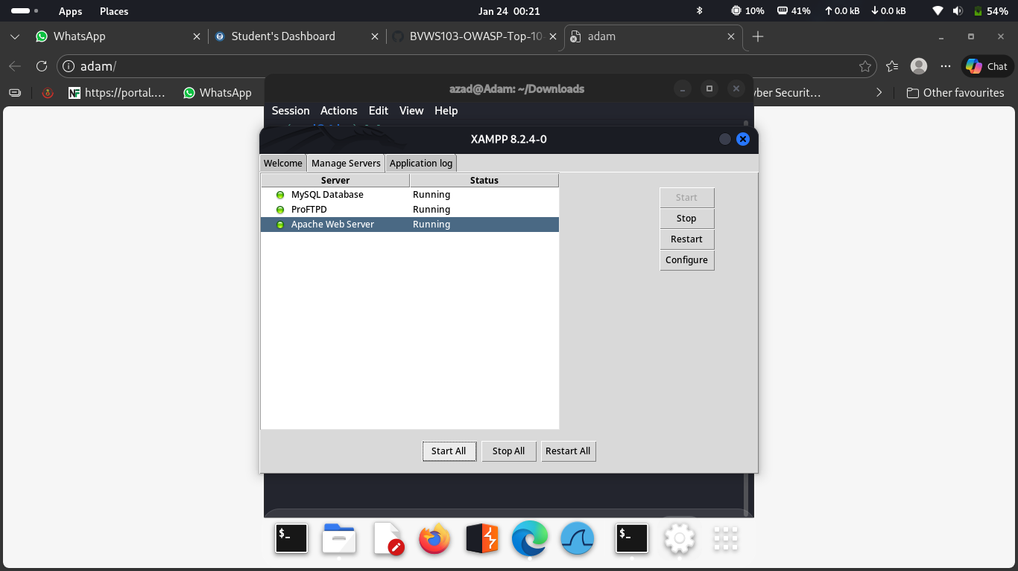

Then I went back again to start it in the terminal by using the command “sudo /opt/lampp/lampp start”

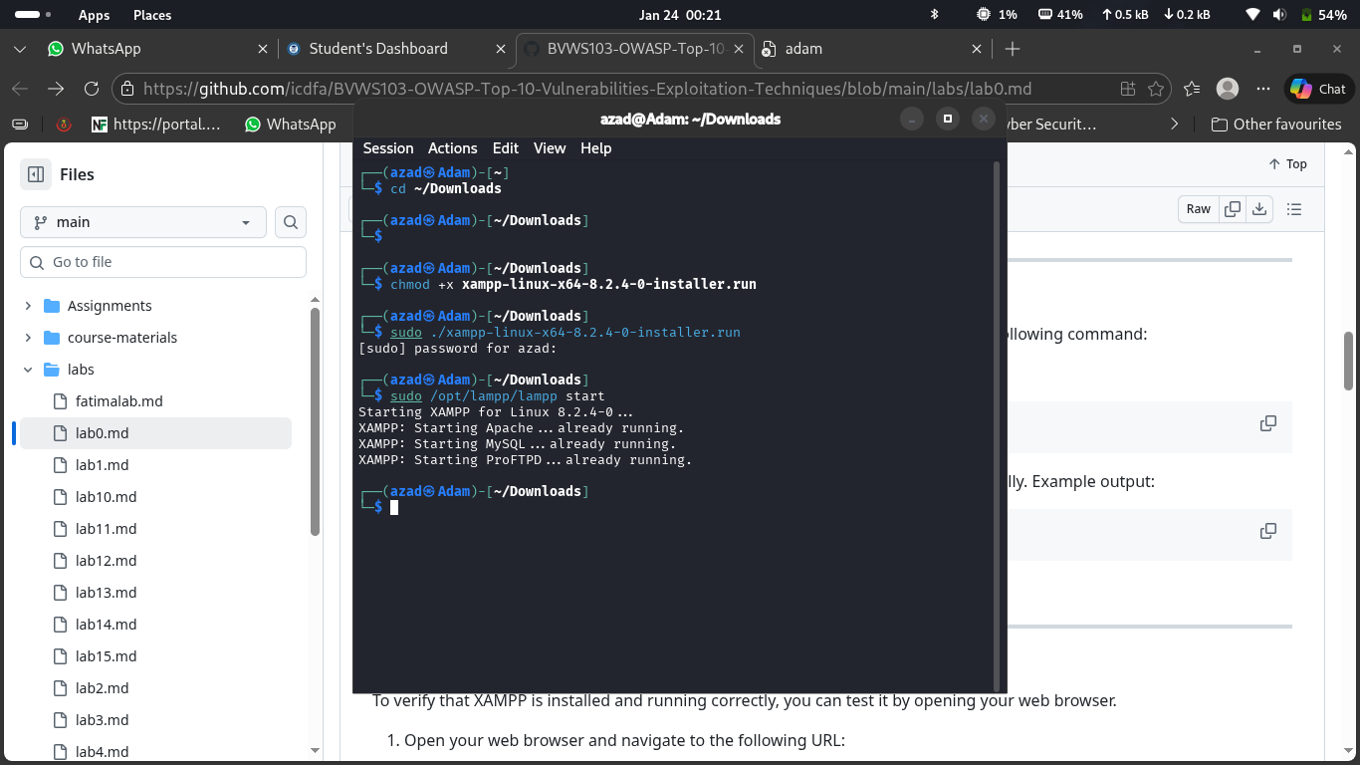

I verify the installation by visiting the localhost server in my browser using the url “http://localhost”

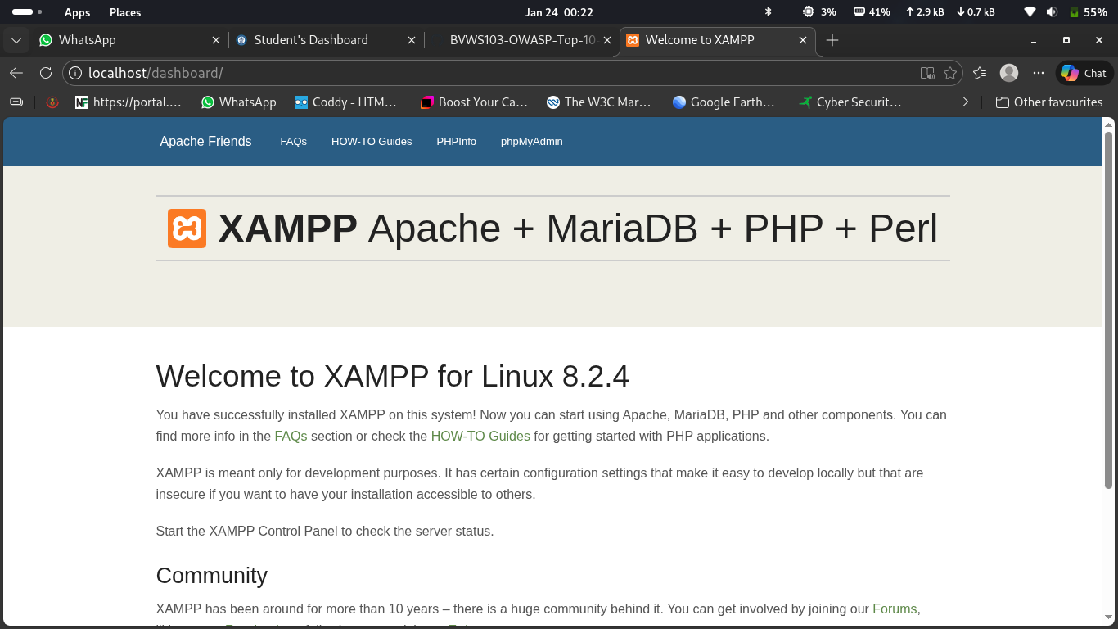

I run a perticuler test to verify the functionality of my XAMPP so I navigate to the root directory using the command “cd /opt/lampp/htdocs” I then opent a .txt file using “sudo nano test.php” and the write a simple script on it

“<?php
phpinfo();
?>”
then I run this “http://localhost/test.php” in my browser

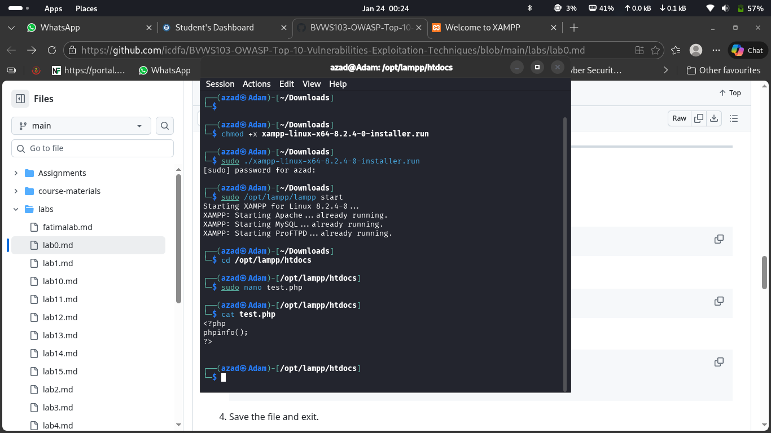
Then this is the output of the test

